**Cuteness research**

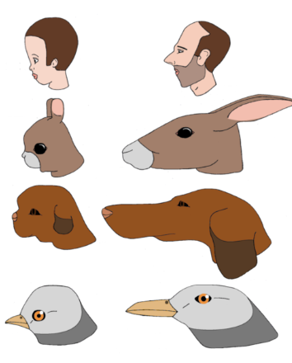

Kindchen Schema - a set of facial and body features that make a creature appear "cute" and activate ("release") in others the motivation to care for it

larger heads, eyes, and chubby cheeks, round features, soft skin, small

Vsauce, Why Are Things Cute? online video recording, YouTube, 2013, <https://www.youtube.com/watch?v=Z0zConOPZ8Y> 